Do you enjoy meeting your friends over coffee or tea? Offer to them Twix Bites along with the cup and win a trip to Sri Lanka!

What comes to your mind when you hear about a cup of coffee or tea? Hot beverages tend to be an essential part of our daily rituals and in our minds they’re often connected to well-deserved relaxation, calm moments and good company. Even more so when you have a little bit of chocolate or some biscuits along with it… If you choose Twix Bites you can have both in a convenient package made for sharing. Whenever you have Twix in your hands it is never too difficult to find company so all that is left to do is decide whether to choose the left of the right Twix bar, who to offer the other one to or if you would rather share little pieces of the favorite chocolate bar from Twix Bites package. And if you’re lucky you can even win a trip to Sri Lanka. Find out more at www.twix.hu.

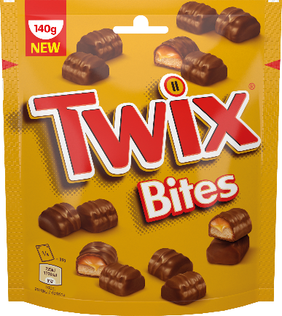
Both tea and coffee belong to the most consumed non-alcoholic beverages in the world and in many occasions biscuits tend to be their companion. So if hot beverages are a part of your daily rituals as well, make pleasant atmosphere even stronger with Twix. It doesn’t matter if you enjoy your coffee or tea at home, at work, while visiting someone or while traveling, Twix Bites come in a convenient package that you can always have on your hand. Inside the popular chocolate bars are divided into smaller pieces made to be shared with others with no redundant extra wrappers. If you share something you also naturally avoid overconsumption.

Both the left and the right Twix bars now joined forces with other popular brands to offer to all tea and coffee enthusiasts a chance to win a trip to one of the most desirable destinations in the world – to exotic Sri Lanka where you will be able to visit tea and coffee plantations and get to know your favorite beverage even better.

To get involved in the contest all you have to do is buy any Twix, Snickers, Mars, Bounty or M&M’s products for at least 600 HUF anytime between February 18 and March 17, 2019. Use the unique code from your AP (Purchase Ticket) to register at www.twix.hu and hide the receipt well. Afterwards you can look forward to winning daily prize which is a set of two mugs for hot beverages, weekly prize – a coffee machine or the jackpot itself – a trip to sunny Sri Lanka. Will you share?

