**Orbit invites summer feeling with new flavor of juicy oranges**

**We already said our goodbyes to spring and hot summer days and sunny weather are just around the corner. It means that it is ideal time to try new Orbit sugar-free chewing gums with amazing flavor of fresh juicy oranges. Ladies and gentlemen we introduce to you Orbit Orange.**

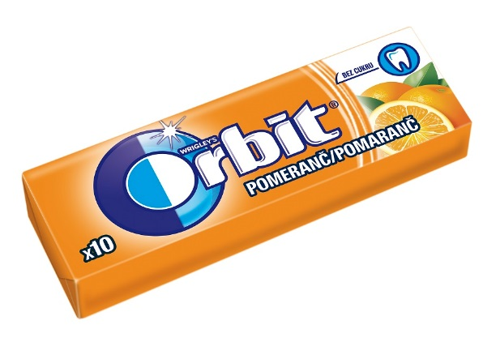

Hot tropical temperatures make us want to go to a beach and relax in shadow under trees. In our minds summer time is also without a doubt connected to juicy fruit which provides amazing refreshment. Now popular sugar-free Orbit chewing gums with new orange flavor can give you just that. Relax in cooling shadow under parasol and sink into delicious flavor of Orbit Orange sugar-free chewing gums, for instance after a light snack or refreshing drink. Don’t be afraid to enjoy freshly squeezed orange juice. Orbit Orange chewing gums will make delicious taste of oranges last even longer and they also help to protect your teeth and ensure healthy and shiny smile. Find out more at [www.orbit.hu](http://www.orbit.hu).

**For more information please reach out to:**

***További információ:***

**Fanni Juhász**

Account Manager

Mobil:+36 30/685-83-10

E-mail: [fanni.juhasz@sterncom.hu](mailto:fanni.juhasz@sterncom.hu)

cid:C702CF42-FB86-4531-8485-2A88545A0E89@mtoffice.hu

______________________________________________________________________

***Orbit*** *is leading brand of chewing gums without sugar and it focuses not just on dental benefits of chewing gums but also on beautiful and healthy smile which helps to boost self-esteem and desire to smile in any situation. It also aims to shine light on importance of regular and right dental hygiene. Orbit brand connects these aspects and continuously stresses idea that self-esteem and desire to smile comes naturally with clean teeth and its altogether healthiness which Orbit chewing gums without sugar help to achieve. Chewing gums without sugar are simple and practical way to support healthy and beautiful smile and they also enable us feel better in any situation.*